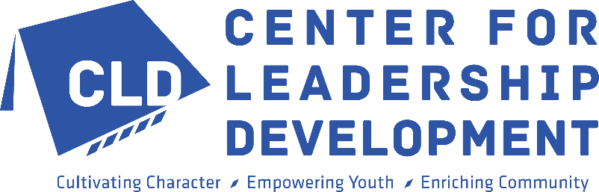

Consider making a legacy gift to Center for Leadership Development…
Planned, deferred or legacy giving is a simple, convenient way to make a lasting impact through incorporating Center for Leadership Development in your estate. Your planned gift can be as specific as a dollar amount for a single purpose or as broad as a residual unrestricted percentage.

PLANNED GIFT TERMS TO KNOW AND EXAMPLES
TYPES
Specific gifts: are made with a dollar amount, asset (such as securities, real estate, personal property, etc.) or percentage of an estate in mind.

Example of cash or stock: “I give to the Center for Leadership Development, a non-profit organization located at 2425 Dr. Martin Luther King Jr. Street, Indianapolis, IN 46208, the sum of $_________ (or________ shares of _______ stock) to be used for its general charitable purposes.”
Example percentage of estate: “I give to the Center for Leadership Development, a non-profit organization located at 2425 Dr. Martin Luther King Jr. Street, Indianapolis, IN 46208, _________% of my estate for its general charitable purposes.”

Residuary gifts: are made with the remainder of an estate, after expenses and disbursements to beneficiaries have been made, in mind.

Example of residuary gift of estate: “I give to the Center for Leadership Development, a non-profit organization located at 2425 Dr. Martin Luther King Jr. Street, Indianapolis, IN 46208, _________% of the remainder of my estate for its general charitable purposes.”

PURPOSE
Unrestricted gifts: are made to allow all funds to be allocated wherever the need is greatest. Unrestricted gifts are the most beneficial to an organization.

Example of unrestricted gifts: “I give to the Center for Leadership Development, a nonprofit organization located at 2425 Dr. Martin Luther King Jr. Street, Indianapolis, IN 46208, the sum of $_______ in cash (or _____shares of _____stock) to be used for its general charitable purposes.”

Restricted gifts: are made with a specific program, service or purpose in mind and should reflect your philanthropic interests (character development, career exploration, tutoring, counseling, etc.)
If the gift is restricted for a specific purpose, it is important that the following wording be added to ensure that, in case the specific purpose is no longer applicable, an alternate use of the funds may be determined:
“If changed circumstances should at some future time make it impractical to administer the fund for the purpose designated, then the Center for Leadership Development President may redesignate the purpose, provided the terms adhere as closely as possible to my original intent.”
Example of restricted gifts: “I give to the Center for Leadership Development, a nonprofit organization located at 2425 Dr. Martin Luther King Jr. Street, Indianapolis, IN 46208, the sum of $_______ in cash (or _____shares of _____stock) to be used for _______________________ at Center for Leadership Development. If changed circumstances should at some future time make it impractical to administer the fund for the purpose designated, then the Center for Leadership Development President may redesignate the purpose, provided the terms adhere as closely as possible to my original intent.”

Please contact Joi Edwards, Director of Development, at 317-923-8111 ext. 309 or jedwards2@cldinc.org to share the news of your planned gift or for more information.

